The accompanying images can be downloaded here:<https://publitekltd.sharepoint.com/:f:/s/PublitekFTP/ErXgHN6lJTFBq6tGvSU70HsBinRYFjvO65tF6vhfLLlixA?e=6cnl8i>

BEUMER Group at [PROMAT 2025](https://www.promatshow.com/) (17-20 March), Chicago, IL: Booth #S1552 (South Hall)   
  
**BEUMER Group sets new standards in fully automated logistics**

* Lights-out automation: BEUMER Group is driving the vision of fully automated systems in the warehouse & distribution sector with pioneering concepts
* AutoDrop live in action: innovative unloading technology for automatic and space-saving unloading demonstrated at PROMAT 2025
* Dynamic Bulk Pick: Intelligent robot solutions for the automated and efficient loading of loop and line sorters

**Somerset, NJ, 11 March 2025 – BEUMER Group is exhibiting at PROMAT 2025 (Booth #S1552, South Hall) under the motto “Your Partner of Choice”. As a strong partner for the intralogistics industry, BEUMER Group supports companies in automating their processes and counteracting the increasing challenges posed by labor shortages. The new AutoDrop function for the BG Pouch System enables automated, space- and weight-optimized unloading of conveyed goods to ensure a smooth material flow in logistics centers. This innovation is complemented by advanced robotic systems that range from robot-assisted loading of pouch sorters and automatic gripping of products from the bulk flow to emptying containers and packing orders. With these technologies, BEUMER Group is strengthening its role as a pioneer for fully automated lights-out warehouses that enable 24-hour operation.**

Efficiency and automation are top priorities in modern logistics centers that are facing growing challenges such as staff shortages and increasing market demands. This is particularly true for companies in the fashion, e-commerce, pharmaceutical, courier, express and parcel services sectors. With the introduction of the AutoDrop function, BEUMER Group offers a simple, robust and reliable solution for pouch sorters that eliminates manual handling during unloading and significantly shortens order throughput times. The BG Pouch System with AutoDrop can process up to 10,000 pieces per line per hour. At the same time, the space required in the unloading area is significantly reduced. The AutoDrop technology is based on an innovative shape memory alloy that is activated by an electric current, enabling automatic opening and closing of the pouches. This process is extremely low-wear and does not burden the pockets with unnecessary weight. Several adjustable unloading points along an unloading route increase flexibility to meet different requirements. The AutoDrop system has already proven itself in the distribution center of an Italian fashion customer and will now be presented to the public at PROMAT 2025 in Chicago.

**Efficient robot-assisted automation**

BEUMER Group also supports companies in the end-to-end automation of their intralogistics processes with robot-assisted systems. These include systems for loading pouch and sorting systems as well as for automatically picking products from the bulk flow (Dynamic Bulk Pick). In the latter, BEUMER uses standard robots in combination with advanced image recognition technology and artificial intelligence to ensure precise identification and handling of products. This automated approach reduces repetitive manual activities, particularly in the loading or goods receiving area, and frees up operating personnel for other tasks. With the robot-assisted picking of products in mass flow, BEUMER Group enables its customers to automatically feed loop and line sorters with an output of around 1,600 picks per hour (pph).

The range of robot-supported automation also includes container tipping stations and packaging in cartons or shipping bags. In addition, the BEUMER stretch hood provides customers with a stretch hood process for pallets that enables fast and secure packaging of goods for production and handling logistics.

“Our goal is to support our customers in automating their processes intelligently and efficiently,” explains Gregor Baumeister, Director Warehousing & Distribution Logistic Systems at BEUMER Group. “We rely on proven technologies and innovative technology transfers and use them to implement sophisticated and future-oriented intralogistics systems. With our extensive portfolio of ideas and systems, we offer customized automation that is precisely tailored to the needs and challenges of our customers.”

*4,284 characters (including spaces)*

**Captions**:

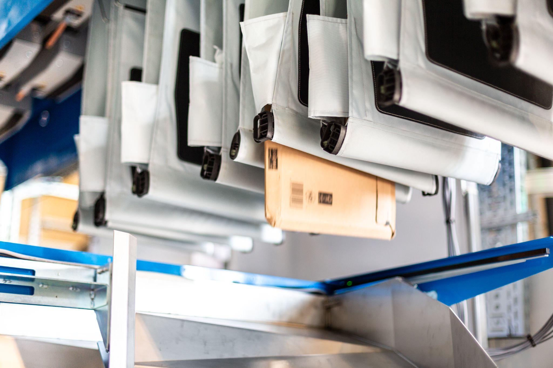

**Image 1**: An AutoDrop function in the BG Pouch System enables complete automation of the unloading process.

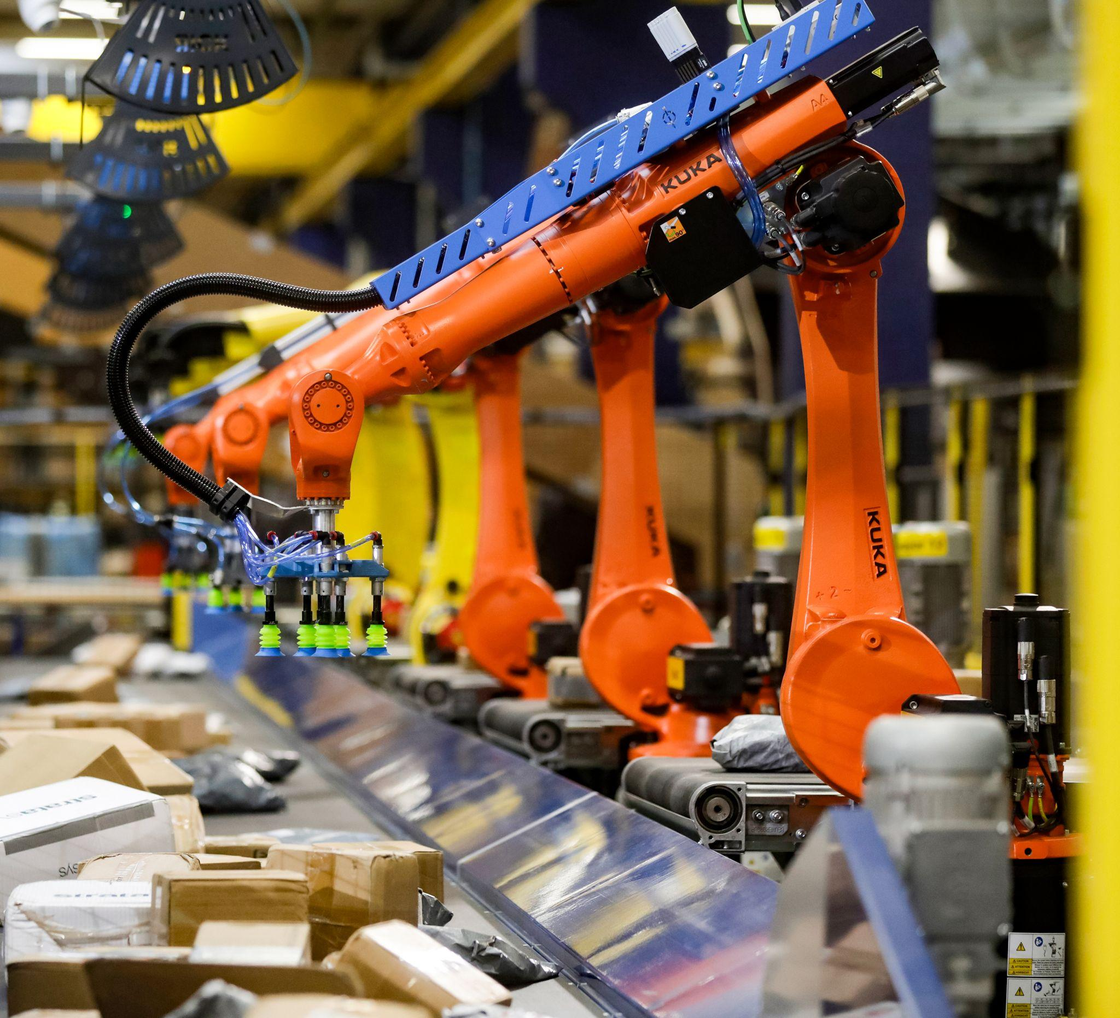

**Image 2:** Dynamic Bulk Pick: Robot-supported automation allows products to be precisely removed from the bulk flow and replaces manual or semi-automatic loading of loop and line sorters.

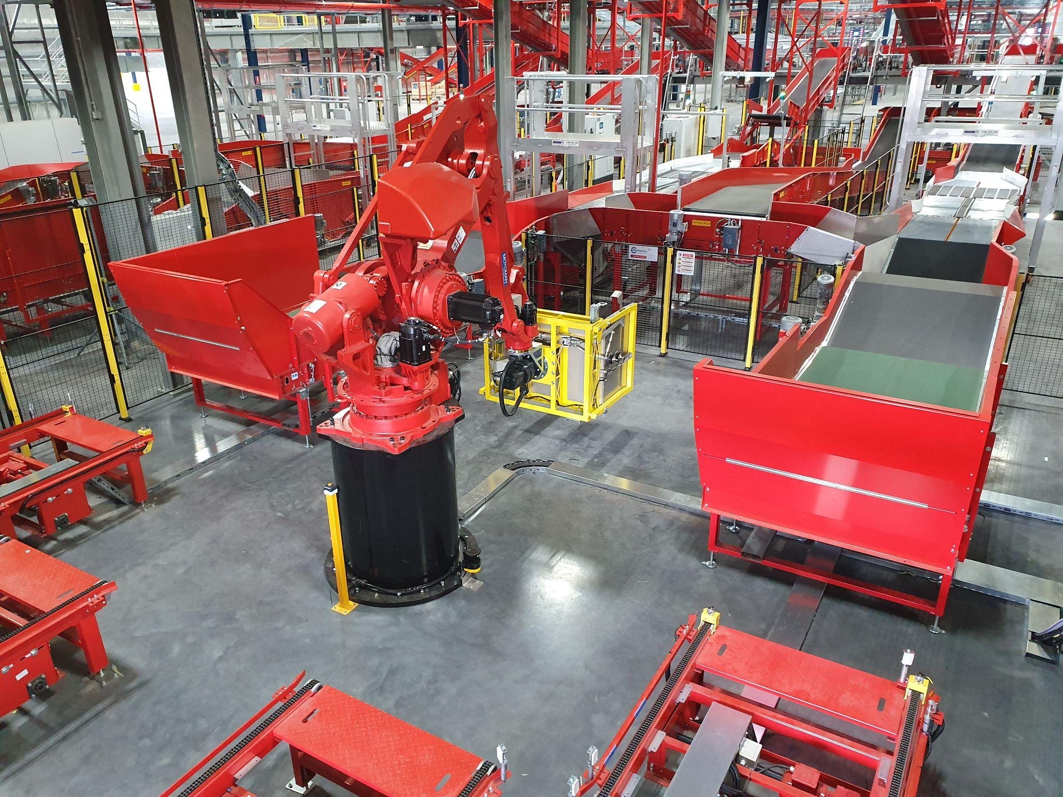

**Image 3:** Robot-assisted container unloading: This container tipping station at the Australian Post parcel distribution center in Brisbane shows how robots unload containers efficiently and automatically.

**Photo Credit:** BEUMER Group GmbH & Co. KG  
Click [here](https://publitekltd.sharepoint.com/:f:/s/PublitekFTP/ErXgHN6lJTFBq6tGvSU70HsBinRYFjvO65tF6vhfLLlixA?e=6cnl8i) to download a high-res version of the images.

**About BEUMER Group**BEUMER Group is a global manufacturer of material handling solutions. As a third-generation family-owned business, the company offers high-quality system solutions and comprehensive customer support worldwide and is a “Partner of Choice” for the mining, cement, building materials, petrochemical, consumer goods, postal, e-commerce, fashion, and baggage handling industries. With 5,600 employees worldwide, BEUMER Group generates an annual order intake of around 1.25 billion euros. In line with the company motto "made different", BEUMER commits to the highest standards of quality, innovation and sustainability. For more information, please visit [www.beumer.com](http://www.beumer.com)

**Press Contact**

**Jackie Sessler:**   Phone +1 (816) 245-7262, Mail: [jackie.sessler@beumer.com](mailto:jackie.sessler@beumer.com)