BEUMER Group enhances Pouch System with innovative AutoDrop feature

- AutoDrop enables zero-touch throughout the pouch handling process including buffering, sorting and sequencing.
- AutoDrop minimises mechatronics use and reduces unloading area space.
- AutoDrop cuts order lead times by streamlining unloading processes.
Beckum, 23 October 2024 – BEUMER Group has developed an innovative AutoDrop feature for automatic unloading of pouches in the BG Pouch System. The new technology enables high-performance unloading while remaining highly available and consistently reliable. The fashion logistics industry, CEP and e-commerce warehouses, and third-party logistics (3PLs) all stand to benefit from the BEUMER Group Pouch System with AutoDrop.

The AutoDrop feature is made possible by using an innovative shape memory alloy technology. A shape memory actuator activates when the pouch reaches the intended unloading position. The automatic opening mechanism consists of two engaged rail units that separate when activated, enabling the item to drop out of the pouch and into the awaiting packaging.

Using AutoDrop, companies can eliminate manual handling during unloading. This saves time at the unloading stations and reduces order lead time. The BEUMER Group Pouch System with AutoDrop can process approximately 10,000 pieces per line per hour. Multiple, adjustable drop point positions combined together in one single drop line enhance flexibility for different unloading needs, while significantly reducing the physical footprint within a warehouse.

David Bauer, Product Manager Pouch Technology at BEUMER Group, says: “The combination of performance, the ability to transport heavy items and the huge automation degree of BG Pouch System is unique in the market. The AutoDrop feature enables zero-touch for the entire pouch handling process as well as offering customers substantial benefits in terms of reducing order lead time and saving valuable floor space.”

The BEUMER Pouch Solution with AutoDrop is available immediately and worldwide.

For more information about BEUMER Group Pouch Solution with AutoDrop, visit:
https://www.beumergroup.com/products-systems/logistics-systems/bg-pouch-system/

2,118 characters (including spaces)

Captions:

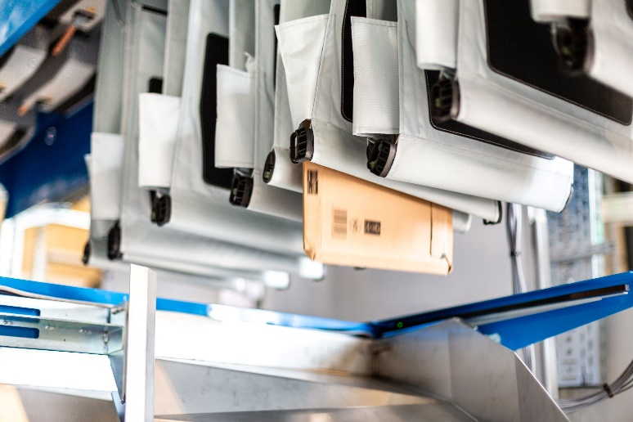
Image 1: A new feature for BG Pouch System enables companies to eliminate manual handling during unloading.

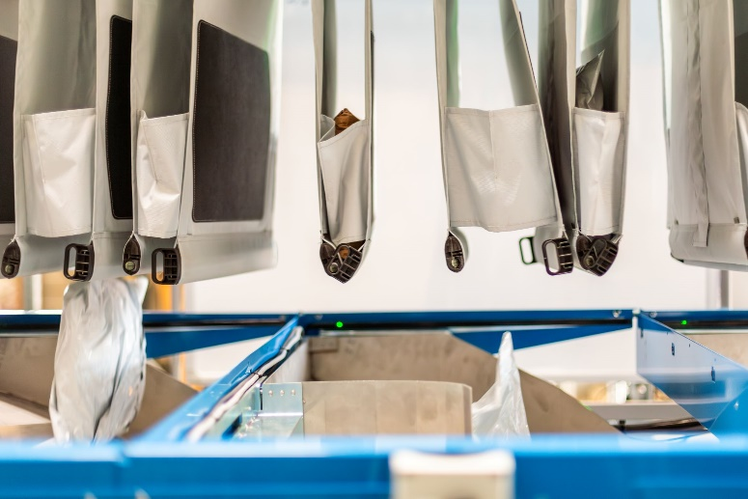
Image 2: AutoDrop uses an innovative shape memory alloy technology.

Photo Credit: BEUMER Group GmbH & Co. KG
Click here to download a high-res version of the images.

About BEUMER Group
BEUMER Group is a global manufacturer of material handling solutions. As a third-generation family-owned business, the company offers high-quality system solutions and comprehensive customer support worldwide and is a “Partner of Choice” for the mining, cement, building materials, petrochemical, consumer goods, postal, e-commerce, fashion, and baggage handling industries. With 5,600 employees worldwide, BEUMER Group generates an annual order intake of around 1.25 billion euros. In line with the company motto "made different", BEUMER commits to the highest standards of quality, innovation and sustainability. For more information, please visit www.beumer.com

Press Contact
Peter Elmvang: Phone + 45 (0) 2721 43 61, Mail: peter.elmvang@beumer.com
Carsten Otte (Agency): Phone +49 (0)4181 968098 80, Mail: carsten.otte@publiktek.com

