**BEUMER Group publishes its annual Airport Report: AIRPORTS 2025 OUTLOOK – REINVENTING THE AIRPORT EXPERIENCE**

* Airports 2025 Outlook draws on a wide range of highly respected sources, including airports, airlines, industry bodies, aviation consultants, researchers and industry media.
* The report shows how airports that invest in innovation and passenger experience will lead the way in industry growth.
* Airports 2025 Outlook offers crucial insights to help airport operators thrive rather than just survive in the new era.

**Beckum, 24 September 2024 –** **BEUMER Group has released their latest annual Airport Report, titled: Airports 2025 Outlook – Reinventing the Airport Experience. The report analyses the state of the industry, including the current challenges airports face. It presents solutions and highlights key focus areas for making airport operations more efficient and improving the passenger experience. Airports of all sizes and in any stage of technology adoption will benefit from the insights in Airports 2025 Outlook.**

In 2025, airports will face increasing capacity challenges to accommodate the surge in global air travel. Current bottlenecks, like security checks, will add even more stress to the travel experience unless airports deploy innovative solutions in their processes. At the same time, labour shortages will need to be addressed through increased automation to meet the high passenger capacity demands.

Airports 2025 Outlook presents the latest technology and automation solutions that are reshaping airport operations and improving passenger experience. It also highlights sustainability strategies to meet the passenger need for improved Environment, Social, and Governance (ESG) performance. The report includes an interview on how the design build approach helped San Francisco Airport towards LEED platinum certification.

Ronald Willems, Division Director Airports Global, for the BEUMER Group, says: “The latest Airports Outlook from the BEUMER Group describes how the industry is further optimising both airport processes and the passenger experience to radically change the way we fly. Inside the pages of this report, we underline how important the passenger experience is to airports heading towards 2025 in what is projected to be a record breaking year for the industry. And the standards are only going to be set higher and higher.”

For more information about Airports 2025 Outlook from the BEUMER Group, visit:

Link to be inserted - [Download report: 2025 outlook - BEUMER Group](https://www.beumergroup.com/knowledge/airport/download-report-2025-outlook/)

*2,409 characters (including spaces)*

**Captions**:

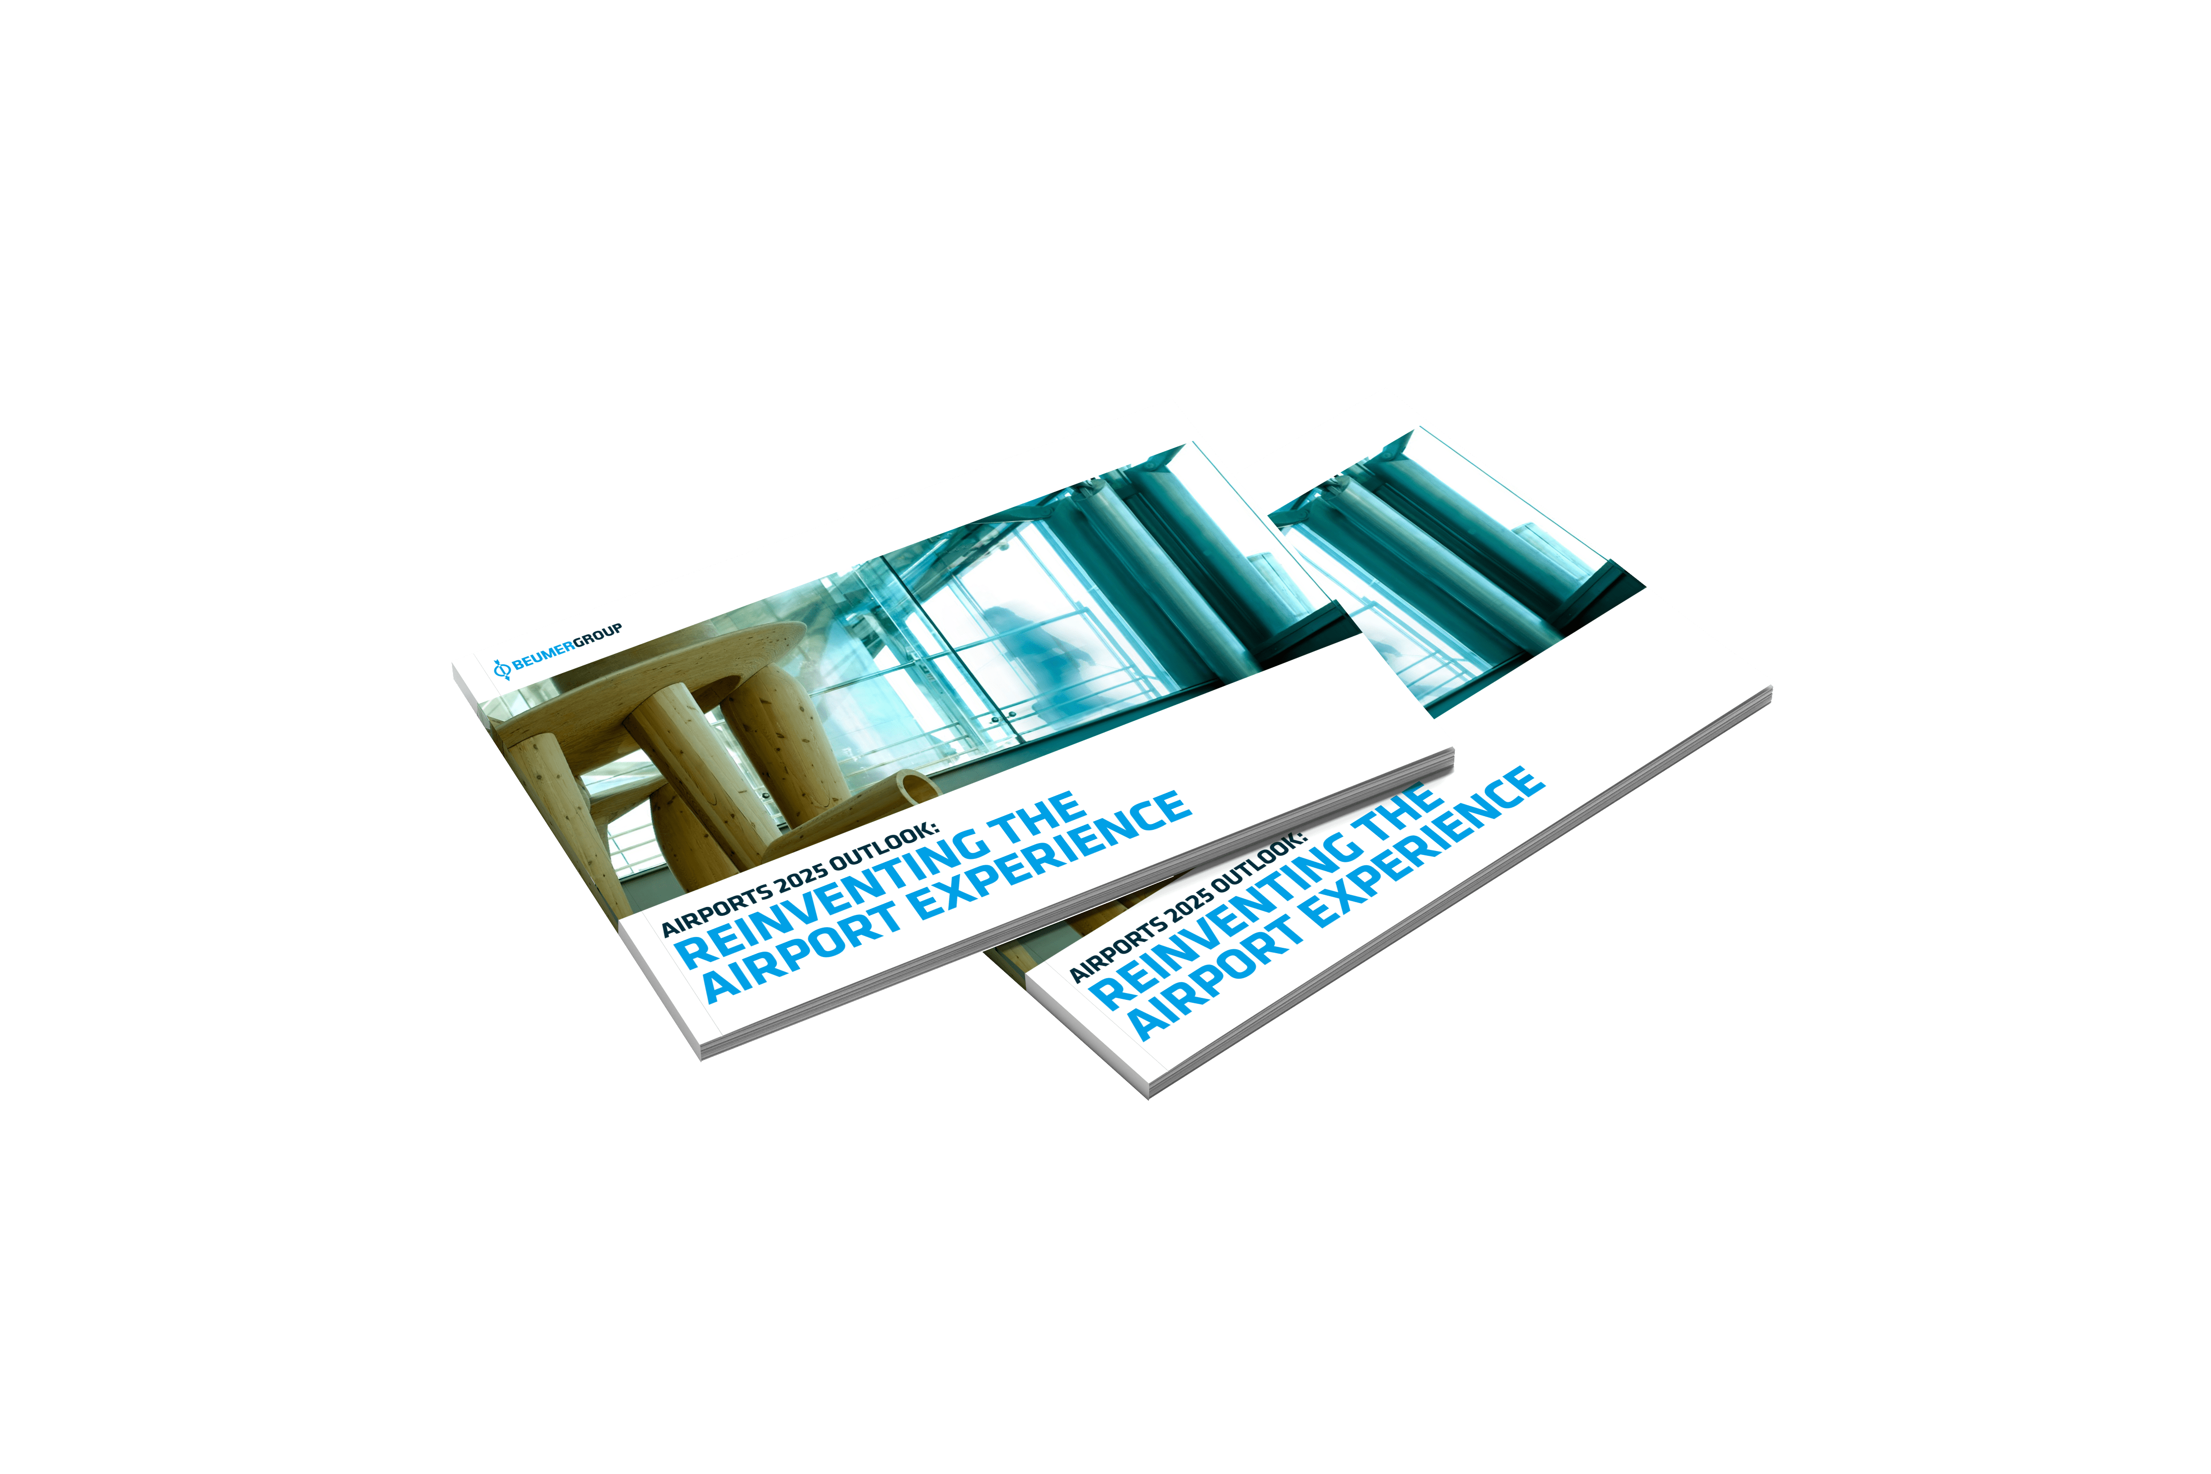

**Image 1:** BEUMER Group’s annual Airport Report: AIRPORTS 2025 OUTLOOK – REINVENTING THE AIRPORT EXPERIENCE.

**Image 2:** BEUMER Group's report offers crucial insights to help airport operators not just survive but thrive in a new era.

**Photo Credit:** BEUMER Group GmbH & Co. KG

Click [here](https://publitekltd.sharepoint.com/:f:/s/PublitekFTP/EoDpmCOVPd9JuX9TYmHuUE4BJryg1vhrE1VICLWcBqpS0w?e=pYn1PZ) to download a high-res version of the image.

**About BEUMER Group**BEUMER Group is a global manufacturer of material handling solutions. As a third-generation family-owned business, the company offers high-quality system solutions and comprehensive customer support worldwide and is a “Partner of Choice” for the mining, cement, building materials, petrochemical, consumer goods, postal, e-commerce, fashion, and baggage handling industries. With 5,600 employees worldwide, BEUMER Group generates an annual order intake of around 1.25 billion euros. In line with the company motto "made different", BEUMER commits to the highest standards of quality, innovation and sustainability. For more information, please visit [www.beumer.com](http://www.beumer.com)

**Press Contact**

Peter Elmvang:     Phone + 45 (0) 2721 43 61, Mail: [peter.elmvang@beumer.com](mailto:peter.elmvang@beumer.com)

Carsten Otte (Agency): Phone +49 (0)4181 968098 80, Mail: [carsten.otte@publiktek.com](mailto:carsten.otte@publiktek.com)