BEUMER Group at [Airports Council International 2024](https://airportscouncil.org/conference/2024-annual-conference-and-exhibition/)

Booth 1027, Grand Rapids, 7-10 September

**BEUMER Group unveils new automated airport security screening solution at ACI 2024 that dramatically improves operational efficiency**

* Optimizes flow at security checkpoints to improve efficiency and banish bottlenecks
* Biometrics link passengers to baggage in a secure, automated environment
* Compact design integrates effectively into existing terminals

**Denver, CO, 02 September, 2024 – BEUMER Group will be showing its range of automated handling systems for airports at ACI this year, including SECTRO – a new centralized screening solution to replace conventional linear security screening lines (SSLs). Designed to optimize flow, improve security and reduce the organizational pressures involved in keeping passengers and their cabin baggage safe, the SECTRO solution takes full advantage of the latest baggage automation technologies to optimize operations and enhance the passenger experience.**

“Airports are under pressure to make the passenger experience as efficient and stress-free as possible, but to achieve this they need to address multiple logistical, operational and staffing challenges,” says Gernot Pöchgraber, BEUMER’s system expert on the topic. “A major annoyance for airports and passengers alike is today’s screening area, which is synonymous with queuing and requires passengers to follow manual divest and reclaim procedures that are not always intuitive. This outdated and very manual approach is inefficient and labor-intensive: none of which makes this mandatory part of flying a pleasant experience.”

**SECTRO rethinks screening**

BEUMER Group has applied its specialist baggage handling automation knowledge to develop the SECTRO solution, with a focus on eliminating delays and minimizing risk to deliver significant benefits for passengers and airport operators alike. Providing an automated solution for today’s airport, SECTRO re-introduces flow to eliminate inefficient queuing, minimizes the risk of lost possessions during check-in, and reduces organizational pressure to keep passengers and their cabin baggage safe. Its compact design also makes the system simple to integrate into existing terminals. One module can handle peaks of around 1000 passengers per hour.

The SECTRO solution totally rethinks the passenger screening experience. It replaces multiple linear security screening lines (SSLs) with an automated process to guide people seamlessly through passenger and cabin baggage separation. Passengers divest their baggage at one of the self-service stations. A touch screen guides them through the simple procedure to connect their biometric data with their baggage, which then enters a sealed and automated system. While it is being checked, the passenger proceeds through the body scanner to reach the information point. Another screen here shows when their baggage is ready for collection using their unique biometric ID. If the automated baggage checks raise any issues, the passenger is directed into a re-check isle where staff can assist.

The SECTRO solution is very flexible and can easily handle peak flows. It allows slower passengers to be overtaken, preventing bottlenecks. The automated baggage checking process is fully centralized, designed to optimize flow, and can achieve up to 30 percent savings in operational resources for the airport. BEUMER Group estimates that the cumulative benefits will save airports millions of euros over the next decade.

For more information, visit BEUMER Group on Booth 1027 at Airports Council International 2024.

*3,667 characters (including spaces)*

**Captions**:

**Picture 1:**

BEUMER Group’s new SECTRO automated screening solution provides airports with more operational efficiency. One module can handle peaks of around 1000 passengers per hour.

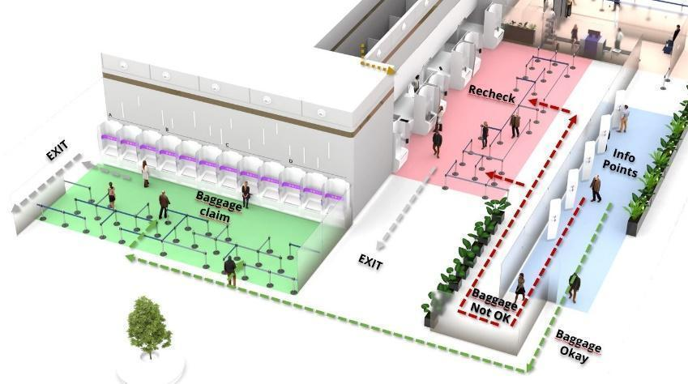

**Photo Credit:** BEUMER Group GmbH & Co. KG

Click [here](https://publitekltd.sharepoint.com/:i:/s/PublitekFTP/Ef-Hm_VEIylHqA46odGLX_8BdE8-iGIrqbl7HrqV1zu0Pw?e=Fshw2T) to download a high-res version of the image.

**About BEUMER Group**BEUMER Group is a global manufacturer of material handling solutions. As a third-generation family-owned business, the company offers high-quality system solutions and comprehensive customer support worldwide and is a “Partner of Choice” for the mining, cement, building materials, petrochemical, consumer goods, postal, e-commerce, fashion, and baggage handling industries. With 5,600 employees worldwide, BEUMER Group generates an annual order intake of around 1,25 billion euros. In line with the company motto "made different", BEUMER commits to the highest standards of quality, innovation and sustainability. For more information, please visit [www.beumer.com](http://www.beumer.com)

**Press Contact**

**Jackie Sessler:**   Phone +1 (816) 245-7262, Mail: [jackie.sessler@beumer.com](mailto:jackie.sessler@beumer.com)

**Carsten Otte (Agency):** Phone +49 (0)4181 968098 80, Mail: [carsten.otte@publiktek.com](mailto:carsten.otte@publiktek.com)