BEUMER Group at [Fachpack 2024](https://www.fachpack.de/de-de) (24-26 September), Nuremberg: Stand 7A-533

**Efficient, sustainable, safe: BEUMER Group showcases latest stretch hood technology at Fachpack**

* Environmentally friendly full pallet packaging with recycling film helps sustainability and legal compliance
* Clever design makes maintenance simpler and improves safety and ergonomics
* Advanced data diagnostics facilitates real-time monitoring

**Beckum, August 1st, 2024 – At this year’s Fachpack, held from 24-26 September in Nuremberg, BEUMER Group will be exhibiting its latest stretch hood technology. With a maintenance-friendly machine design in which all components can be accessed at ground level, along with advanced data diagnostics, the supplier of automated material flow systems contributes to increasing efficiency, safety and ergonomics. In combination with the possibility of using film containing high percentages of recycled material and packaging a wide range of products and pallet formats, BEUMER Group offers its customers solutions that create economic and ecological added value.**

When it comes to packaging solutions, there is an increasing focus on sustainability and efficiency. The European Packaging Directive and the German Packaging Act (VerpackG) are geared towards increasing the amount of recycling and reducing the volume of waste. These regulations call for an increase in the use of recycled materials in packaging film. One of the highlights in Nuremberg will be the BEUMER stretch hood - A packaging machine, which helps customers comply with legal requirements and implement more sustainable packaging processes. It is designed to enable film with a high proportion of recycled material, 30 percent or more, to be processed safely and reliably. The use of thinner yet higher-performance film types also reduces film consumption and hence packaging costs as well. Since the BEUMER stretch hood A can also be implemented in the form of a 2-film format machine, a wide range of pallet formats can be processed without changing the film rolls. In this scenario, the BEUMER stretch hood A calculates the optimum film requirement for each pallet. It therefore ensures the optimum use of the material, which in turn helps reduce the amount of packaging material used and hence the CO2 footprint.

Straightforward and intuitive operation via an ergonomic human machine interface (BEUMER HMI) along with the ability to perform all maintenance and service work without a ladder, platform or lifting truck, mean increased user-friendliness and safety for operators. All components requiring maintenance are accessible directly from the ground or can be lowered until they are close to the ground.

In addition, comprehensive data analytics services of the BEUMER Customer Diagnostic Centre provides customers with the facilities for precise monitoring and optimisation of packaging processes. Thanks to the seamless integration of real-time performance data and advanced management tools, users are given a direct overview of the operating status of their machines. This means that they can proactively identify and implement potential improvements. In addition, BEUMER Group’s team of experts can virtually take a “look over the shoulder” of the customer’s service personnel using BEUMER Smart Glasses and thereby help with efficient problem-solving.

“The BEUMER stretch hood A fulfils the highest standard in terms of loading safety and the protection of resources,” explains Jörg Spiekermann, Head of Sales for Palletising and Packaging Systems Consumer Goods at the BEUMER Group. “We continue to develop our systems and services, to help the transition to ‘lights-out’ operation. This means that physically strenuous work will be increasingly substituted by robots or automation processes, so that humans can concentrate on more productive or administrative tasks. This brings the dark warehouse within tangible reach.”

The BEUMER stretch hood A is suitable for packaging a wide variety of goods, from high-quality electronics to food and beverages as well as palletised building materials. It guarantees a high level of load safety during transport and storage by ensuring the stability of the pallets and minimising the risk of slippage. In addition, it provides effective product protection by shielding the goods from moisture, dirt and unauthorised access.

Visitors to Fachpack 2024 will gain an exclusive overview of the advances in and future of stretch hood technology on Stand 7A-533 of the BEUMER Group. They can exchange ideas with experts on all aspects of sustainability and innovative diagnostics systems and take inspiration from them.

*4,637 characters (including spaces)*

*BEUPR025 BEUMER Fachpack Image 1*

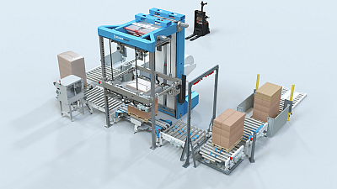

**Caption 1**:The new BEUMER stretch hood offers advantages of ground-level and ergonomically designed operating and maintenance access points.

*BEUPR025 BEUMER Fachpack Image 2*

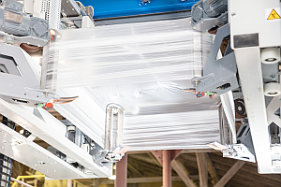

**Caption 2**:BEUMER stretch hood A can process film with a 30 percent proportion of recycled material, or more, safely and reliably.

*BEUPR025 BEUMER Fachpack Image 3*

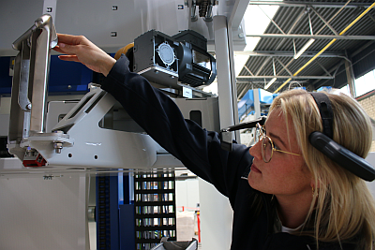

**Caption 3**:The BEUMER Smart Glasses enable the BEUMER team to assist customers by allowing them to virtually “look over the shoulder” of service personnel.

**Photo credits:** BEUMER Group GmbH & Co. KG

Click here to download a high-resolution version of the image.

**About BEUMER Group**  
BEUMER Group is a global manufacturer of material handling solutions. As a third-generation family-owned business, the company offers high-quality system solutions and comprehensive customer support worldwide and is a “Partner of Choice” for the mining, cement, building materials, petrochemical, consumer goods, postal, e-commerce, fashion, and baggage handling industries. With 5,600 employees worldwide, BEUMER Group generates an annual order intake of around 1.25 billion euros. In line with the company motto "made different", BEUMER commits to the highest standards of quality, innovation and sustainability. For more information, please visit [www.beumer.com](http://www.beumer.com/)

**Press Contact**

**Verena Breuer:** Tel. + 49 (0) 2521 24 317 Mail: [verena.breuer@beumer.com](mailto:verena.breuer@beumer.com)