**Warrior Met Coal selects BEUMER Group to build a long-distance overland conveyor for its mine expansion in Alabama**

* Warrior Met Coal selects BEUMER Group to support mine expansion
* BEUMER Group’s troughed belt conveyor solution enables efficient coal transportation
* Proactive partnership pivotal to successful planning and implementation of project

**Denver, CO, 13 August 2024 – BEUMER Group has been selected by Warrior Met Coal ("Warrior") to support the expansion of Blue Creek Mine, a new state of the art underground longwall mine of high quality steelmaking coal. The extracted steelmaking coal will be processed at the surface in a coal preparation plant before being moved over nine miles (14 km) to a train loadout station.**

The BEUMER Group recently secured the order from Warrior to design and supply a single-flight curved overland conveyor for this 1,500 Short Ton Per Hour (STPH) transport system. Daniel Schmillenkamp, CEO of BEUMER Group Canada, comments: “In cooperation with Warrior, we addressed the project-specific challenges. The design and implementation are a testament to our commitment to innovation and customer-centric solutions.”

The project presented some challenges due to the difficult and hilly terrain of the proposed transport corridor. To find the most efficient solution, Warrior explored various transportation methods, including rail, troughed, and pipe conveyor systems. Over the past 12 months, BEUMER Group has worked closely with Warrior to identify the most economical and technically feasible transport method and optimal route, resulting in a single conventionally troughed conveyor with 18 horizontal curves.

Philip Saunders, Senior VP-Engineering at Warrior, commented that “BEUMER's holistic approach and our very close working relationship allowed us to expedite the design and procurement phase to move toward the completion of this time-sensitive project at a pace rarely seen in the coal or mining industries.”

BEUMER Group is responsible for engineering and procurement of all structural, and mechanical components and multiple E-Houses with VFDs, MCCs, and PLC control systems. The conveyor system will utilize nine load-sharing drives to limit the overall belt tension.

BEUMER's Director of Sales, Peter Sehl, explained that this project utilizes innovative and proprietary conveyor engineering and design tools to support the fast construction schedule. "With over 5,000 tons of steel for ground modules and elevated sections, 47% of the conveyor flight will be elevated to avoid natural features and minimize earthworks."

The overland conveyor is expected to be operational by the end of 2025.

*2,649 characters (including spaces)*

**Captions**:

*BEUPR024 Picture 1*

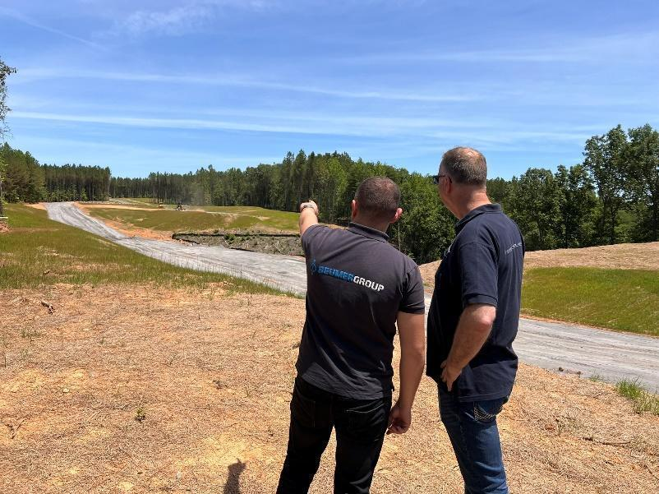

Picture 1: Site preparation work for the BEUMER Overland Conveyor commenced in March 2024

**Photo Credit:** BEUMER Group GmbH & Co. KG

Click here to download a high-res version of the image.

**About BEUMER Group**  
BEUMER Group is a global manufacturer of material handling solutions. As a third-generation family-owned business, the company offers high-quality system solutions and comprehensive customer support worldwide and is a “Partner of Choice” for the mining, cement, building materials, petrochemical, consumer goods, postal, e-commerce, fashion, and baggage handling industries. With 5,600 employees worldwide, BEUMER Group generates an annual order intake of around 1,25 billion euros. In line with the company motto "made different", BEUMER commits to the highest standards of quality, innovation and sustainability.

For more information, please visit [www.beumer.com](http://www.beumer.com)

**About Warrior Met Coal**

Warrior is a U.S.-based, environmentally, and socially minded supplier to the global steel industry. It is dedicated entirely to mining non-thermal metallurgical (met) steelmaking coal used as a critical component of steel production by metal manufacturers in Europe, South America, and Asia. Warrior is a large-scale, low-cost producer and exporter of premium quality met coal, also known as hard-coking coal (HCC), operating highly efficient longwall operations in its underground mines based in Alabama. The HCC that Warrior produces from the Blue Creek coal seam contains very low sulfur and has strong coking properties. The premium nature of Warrior’s HCC makes it ideally suited as a base feed coal for steel makers.

For more information, please visit [www.warriormetcoal.com](http://www.warriormetcoal.com).

**Press Contact**

**Verena Breuer:** Phone + 49 (0) 2521 24 317, Mail: [verena.breuer@beumer.com](mailto:verena.breuer@beumer.com)

**Carsten Otte (Agency):** Phone +49 (0)4181 968098 80, Mail: [carsten.otte@publiktek.com](mailto:carsten.otte@publiktek.com)