BEUMER Group sets up state-of-the-art production site
in Reliance MET City/India

- Foundation stone ceremony for INR 2 billion investment
- First German company to set up production in "Model Economic Town"
- New site plays a pivotal role in BEUMER's global factory network
Jhajjar/Haryana, 02 July 2024 – BEUMER Group is continuing on its growth path and expanding its commitment in India. The global manufacturer of material handling solutions invests more than INR 2 billion in a new, state-of-the-art production city in Reliance MET City/Jhajjar. Laying of the foundation stone took place on 27 June 2024, with representatives of BEUMER Group and Reliance MET City attending the ceremony.

The new production site will further strengthen BEUMER's global factory footprint as well as boosting the continued success of its BEUMER India subsidiary. With an area of more than ten acres, the new plant will be placed at a highly strategic location, with Reliance MET City offering exemplary infrastructure and support. BEUMER will be the first German company to set up production in the development zone. Construction work will commence this Summer, the inauguration of the new plant is scheduled for September 2025.

BEUMER Group has been active in India since 2003. Initially catering to the cement industry exclusively, BEUMER India has grown significantly over the years and now offers solutions for the airport industry, minerals and mining, for automated warehouses and distribution centres in the retail industry as well as in the areas of e-commerce and courier, express and parcel. In addition, BEUMER India is also providing engineering support to the group's global network.

On the product side, BEUMER India has been a trailblazer of new bulk as well as discrete material handling technologies to India, for example: high-capacity, high-speed automatic loop sortation for passenger baggage, fully automated truck loading for cement bags, high-efficiency bulk material transport, as well as curved belt and pipe conveyors.

Over the years, BEUMER strengthened its position in India through various steps, such as diversifying to all business segments as global operations, acquisition of ENEXCO Technologies India, FAM India and the establishment of a modern manufacturing unit at Naurangpur, Haryana.

"This expansion reflects BEUMER Group's strategic focus and commitment to long-term success in India. The new production site plays an important part in our global factory footprint, strengthening our position as a quality leader and partner of choice for our customers", said Rudolf Hausladen, CEO BEUMER Group.

"Our new production site at Reliance MET City offers a convenient ease of business and synergy in approaching infrastructure and facilities with a vision towards sustainable development. Setting up a manufacturing unit in the context is truly 'plug and play', with Reliance staying true to its goal of developing a 'Model Economic Town'", said Nitin Vyas, Cluster Asia CEO, BEUMER Group.

2.726 characters (including spaces)

Captions:
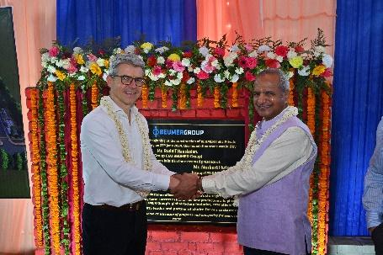
Picture 1: Rudolf Hausladen, CEO of BEUMER Group, at the laying of the foundation stone together with ShriVallabh Goyal, CEO and WTD of Reliance MET City.

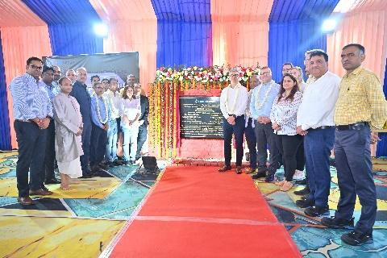
Bild 2: Ceremonial laying of the foundation stone. The new BEUMER production site in India is scheduled to start operations in September 2025.

Photo Credit: BEUMER Group GmbH & Co. KG
Click here to download a high-res version of the image.

About BEUMER Group
BEUMER Group is a global manufacturer of material handling solutions. As a third-generation family-owned business, the company offers high-quality system solutions and comprehensive customer support worldwide and is a “Partner of Choice” for the mining, cement, building materials, petrochemical, consumer goods, postal, e-commerce, fashion, and baggage handling industries. With 5,600 employees worldwide, BEUMER Group generates an annual order intake of around 1.25 billion euros. In line with the company motto "made different", BEUMER commits to the highest standards of quality, innovation and sustainability. For more information, please visit www.beumer.com

Press Contact
Peter Elmvang: Phone + 45 (0) 2721 43 61, Mail: peter.elmvang@beumer.com

