**BEUMER Group extends its operations in South America**

* Offices in Brazil, Peru and Chile follow the acquisition of FAM
* Integration of FAM business completed
* South American customers now enjoy access to the full BEUMER Group portfolio

**Beckum, June 12, 2024 – BEUMER Group has extended its presence in South America with the integration of the former FAM operations in Brazil, Peru and Chile. The move follows the acquisition of FAM Minerals & Mining GmbH in 2022. Now known as BEUMER Group South America, the former FAM operations have become an integral part of the BEUMER family and will offer customers access to the full range of BEUMER automated material handling solutions and services. This milestone demonstrates BEUMER Group’s long-term commitment to customers throughout South America and represents a significant investment into the region.**

Continuity of service is assured as Paulo Costa, former head of FAM operations in the region, has been appointed as the new CEO of BEUMER South America. Paulo says: “FAM had a strong reputation within the mining and minerals industry in Brazil, Peru, Chile and beyond, which gives us a strong foundation to build upon. As part of BEUMER Group, we will continue to support our customers in mining and minerals, while also expanding our reach to offer high quality handling solutions for airports, ports and terminals, warehousing and logistics to customers throughout South America.”

BEUMER Group offers global expertise through local presence and puts the customer at the heart of its business. By combining the skills and expertise inherent in the FAM and BEUMER brands, the teams based in Brazil, Peru and Chile will support customers throughout South America to deploy handling solutions that improve efficiency and drive down operational costs. The strategically located offices further enable BEUMER Group to respond quickly and efficiently to support customers in the region, delivering outstanding solutions at every stage of the project life cycle to meet the necessary standards and certifications.

*325 words, 2074 characters (including spaces)*

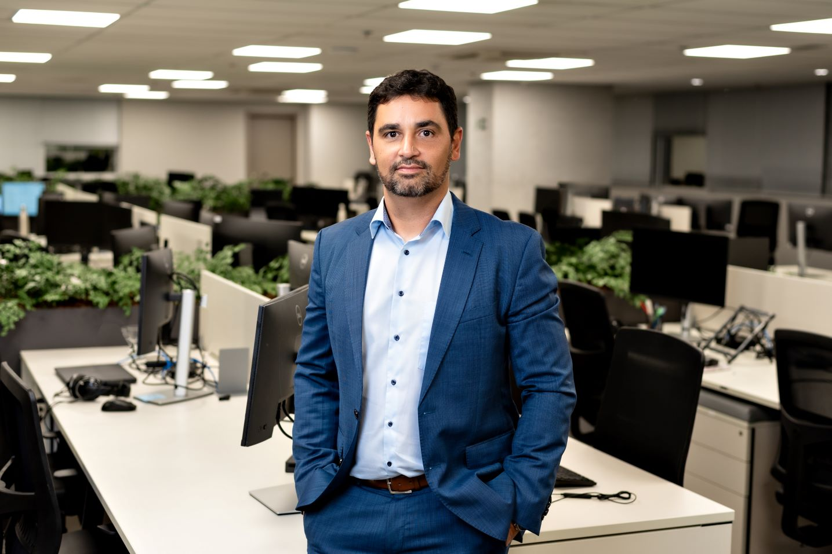

**Caption 1**: Paulo Costa, CEO of BEUMER South America

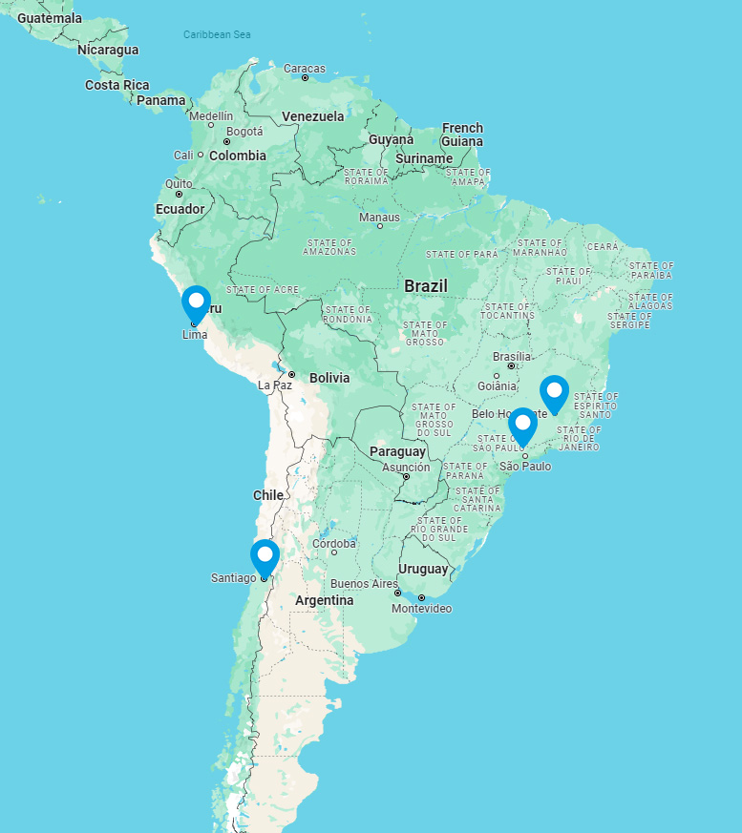

**Caption 2**: BEUMER Group locations in South America

**Photo Credit:** BEUMER Group

Click [here](https://publitekltd.sharepoint.com/sites/PublitekFTP/Shared%20Documents/Forms/AllItems.aspx?id=%2Fsites%2FPublitekFTP%2FShared%20Documents%2FCSH%2FPR%20PICTURES%2FBeumer%2FBEUPR015&viewid=92479ab8%2D4e0c%2D417f%2D8bae%2D7ba634b79200) to download a high-res version of the image.

**About BEUMER Group**  
BEUMER Group is a global manufacturer of material handling solutions. As a third-generation family-owned business, the company offers high-quality system solutions and comprehensive customer support worldwide and is a “Partner of Choice” for the mining, cement, building materials, petrochemical, consumer goods, postal, e-commerce, fashion, and baggage handling industries. With 5,600 employees worldwide, BEUMER Group generates an annual order intake of around 1,25 billion euros. In line with the company motto "made different", BEUMER commits to the highest standards of quality, innovation and sustainability.

For more information, please visit [www.beumer.com](http://www.beumer.com)

**Press Contact**

**Jackie Sessler:**   Phone +1 (816) 245-7262, Mail: [jackie.sessler@beumer.com](mailto:jackie.sessler@beumer.com)

**Carsten Otte (Agency):** Phone +49 (0)4181 968098 80, Mail: [carsten.otte@publiktek.com](mailto:carsten.otte@publiktek.com)