BEUMER Group: Elara Digital offers innovative standard software for maintenance

Innovative maintenance software reduces unplanned machine downtime

Unplanned machine downtime leads to lost time and increased costs. In cooperation with the BEUMER Group, Elara Digital GmbH offers an innovative standard maintenance solution, which optimizes maintenance processes, maximizes the availability of machine assets and reduces the workload of the maintenance team.

The software enables users to schedule time- and meter-based maintenance cycles and informs them of upcoming tasks. It tracks all stoppages through simple status changes and gives users a complete overview. The software also manages all stock levels and simplifies the tracking of spare parts and consumables. It organizes standardized and recurring maintenance tasks and supports companies with their tests and inspections. The software’s reliable and timely performance of all the required activities helps to automate tasks and reduce maintenance costs.

Maintenance staff can immediately access all the relevant information for inspections or troubleshooting by scanning the QR code on the machines or equipment. Malfunctions, repairs and downtime can also be recorded and documented in seconds, ensuring a seamless machine history. The software also offers standard templates for shift supervisors to enter error messages. These templates can be used to create interactive, recurring checklists, eliminating time-consuming handwritten entries.

With this user-friendly mobile application, maintenance staff can record time and costs for maintenance directly in work orders and access documents such as operating instructions and circuit diagrams from anywhere. The application also provides a real-time overview of all the equipment, immediately showing which machines are active.

Elara’s user-friendly interface is optimized for tablets and smartphones. It replaces traditional pen-and-paper methods, enabling production and maintenance workers to organize their workflows efficiently. Elara’s team of experts ensures a smooth implementation and successful rollout, providing a reliable solution for all maintenance needs. Book a no-obligation product demo today: https://rb.gy/yv2ly

2,243 characters incl. blanks

Meta title: Elara Digital: Innovative standard solution for maintenance

Meta description: Together with its partner Elara, the BEUMER Group offers a modern and innovative standard solution for maintenance

Keywords: BEUMER Group; Elara Digital; Intralogistics; Maintenance; Maintenance software

Social media: Unplanned machine downtime costs time and money. Elara Digital GmbH, a strategic partner and part of the BEUMER Group, offers an innovative standard maintenance solution to optimize maintenance processes, maximize the availability of machinery and reduce the workload of the maintenance team.

Captions:

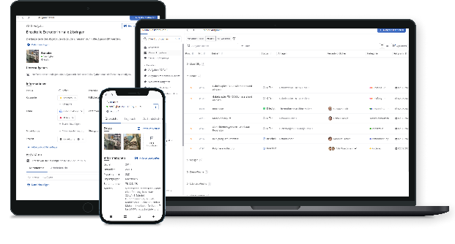
Photo 1: With Elara Digital's modern and innovative maintenance software, maintenance teams have all important information immediately at hand at the point of action.

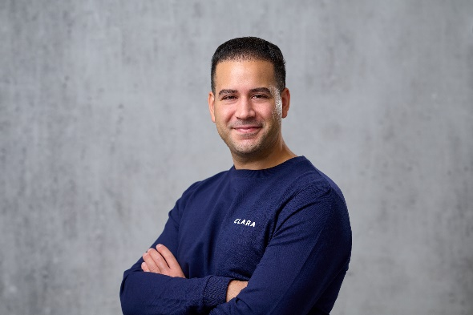

Photo 2: The founders of Elara Digital GmbH: Akram Alraai...

Photo 3: ... and Dominik Adamowski.

Photo credits: BEUMER Group GmbH & Co. KG

The high-resolution picture can be downloaded here.

BEUMER Group is an international leader in the manufacture of intralogistics systems for conveying, loading, palletising, packaging, sortation, and distribution. With 5,400 employees worldwide, BEUMER Group has annual sales of about EUR 1 billion. BEUMER Group and its group companies and sales agencies provide their customers with high-quality system solutions and an extensive customer support network around the globe and across a wide range of industries, including bulk materials and piece goods, food/non-food, construction, mail order, post, and airport baggage handling.

For more information visit www.beumer.com.

