BEUMER Group expands in the USA
More closeness, better support

In addition to the existing office in Somerset, New York, the BEUMER Group has now opened a new office in Denver, Colorado. This merged the offices in Kansas City and Dallas. The new location in Denver is strategically located that all customers can be easily reached. Here, projects in the business areas of mining and airport will be mainly managed. The new location offers space for around 35 workplaces. With this location the BEUMER Group plans to expand further.

“From strategically located Denver now we are very happy to offering our airport customers our baggage handling systems. With our comprehensive range of services, we are always there for our customers“, says David Delaney, Vice President and General Manager Airports Division North America at BEUMER. Furthermore, US customers from the mining business area will also benefit from the new company office. “Out of the new office now, we can look after our customers in the various industries even better", said Daniel Uttelbach, Managing Director and Vice President Conveying & Loading Systems.

1,122 characters including spaces

Meta-Title: BEUMER Group opens location in Denver / USA

Meta description: With the BEUMER Group's new location in Denver / Colorado, the system provider can better serve customers in the Airport and Mining business areas.

Keywords: BEUMER Group; BEUMER Corporation; Location; Airport; Mining; System provider

Social Media: The BEUMER Group, with its North American subsidiary BEUMER Corporation, has opened a new location in Denver / Colorado. With this new headquarters for the Airport and Mining business units, the system provider is closer to its customers.

Captions:
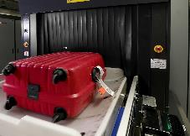
Photo 1: Baggage handling at airports with 100 percent tracking of the baggage in every phase of the check-in process is becoming increasingly important.

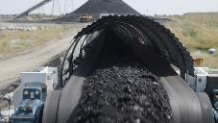
Photo 2: For example, the Overland Conveyor transports coal from the underground mine to the main processing plant.

Photo credits: BEUMER Group GmbH & Co. KG

The high-resolution pictures can be downloaded here.

BEUMER Group is an international leader in the manufacture of intralogistics systems for conveying, loading, palletising, packaging, sortation, and distribution. With 4,500 employees worldwide, BEUMER Group has annual sales of about EUR 950 million. BEUMER Group and its group companies and sales agencies provide their customers with high-quality system solutions and an extensive customer support network around the globe and across a wide range of industries, including bulk materials and piece goods, food/non-food, construction, mail order, post, and airport baggage handling.

For more information visit .www.beumer.com

